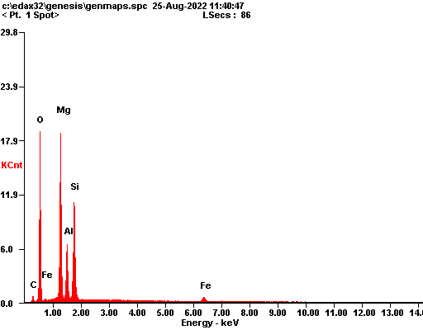

|  |  |  |
| --- | --- | --- |
| ***Element*** | ***Wt%*** | ***At%*** |
| ***CK*** | 05.08 | 08.82 |
| ***OK*** | 34.89 | 45.49 |
| ***MgK*** | 24.45 | 20.98 |
| ***AlK*** | 10.56 | 08.16 |
| ***SiK*** | 19.47 | 14.47 |
| ***FeK*** | 05.55 | 02.07 |
| ***Matrix*** | Correction | ZAF |

